### Temperatures over the last 65 million years

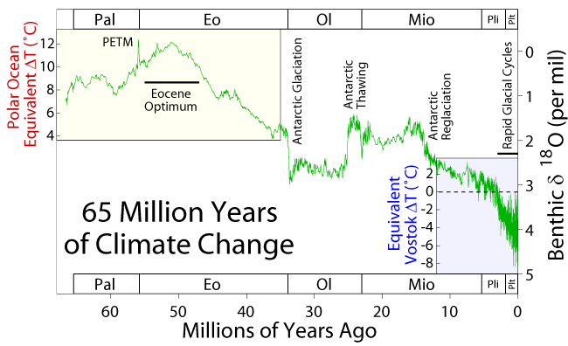

This shows the Earth's temperature since the extinction of the dinosaurs about 65 million years ago - the end of the [Mesozoic](http://www.palaeos.com/Mesozoic/Meszoic.htm) and beginning of the [Cenozoic](http://www.palaeos.com/Cenozoic/Cenozoic.htm). At first the Earth warmed up, reaching its warmest 50 million years ago: the "Eocene Optimum". The spike before that labelled "PETM" is a fascinating event called the [Paleocene-Eocene Thermal Maximum](http://en.wikipedia.org/wiki/Paleocene-Eocene_Thermal_Maximum). At the end of the [Eocene](http://www.palaeos.com/Cenozoic/Eocene/Eocene.htm) the Earth cooled rapidly and the Antarctic acquired year-round ice. After a warming spell near the end of the [Oligocene](http://www.palaeos.com/Cenozoic/Eocene/Oligocene.htm), further cooling and an increasingly jittery climate led ultimately to the current age of rapid glacial cycles - "ice ages".

This chart is taken from here:

* Robert Rohde, [65 million years of climate change](http://en.wikipedia.org/wiki/Image:65_Myr_Climate_Change.png), for [Global Warming Art](http://www.globalwarmingart.com/).